

Project Title:

**Voice/Speech Recognition System**

Submitted by:

**Ebaa Haq [2021-CE-22]**

**Maham Nadeem [2021-CE-10]**

**Faiza Riaz [2021-CE-20]**

Submitted to:

**Sir Raja Muzammil Munir**

Course:

**CMPE-341L Artificial Intelligence**

Semester:

**Fall 2023 (5th)**

Date of Submission:

**[November 17, 2023]**

**Department of Computer Engineering**

**University of Engineering and Technology, Lahore**

Table of Contents

Abstract 3

1. Introduction 3

2. Problem statement 3

4. Proposed Methodology 4

4. Block Diagram 4

5. Flowchart……………………………………………………………………………………………...5

6. Expected outcome/results 5

7. Applications 5

References 6

# 

# Abstract

# Speech recognition, also known as automatic speech recognition (ASR), is the process of converting spoken words into text. It is a complex technology that involves a number of different steps, including signal processing, feature extraction, and pattern recognition. Speech recognition systems have a wide range of applications, including voice control for devices and appliances, transcription of audio recordings, and accessibility for people with disabilities.

# Introduction

In today's increasingly digital world, speech recognition is becoming an essential tool for interacting with machines. It allows us to control devices and appliances with our voices, transcribe audio recordings into text, and access information hands-free. Speech recognition systems are also used in a variety of other applications, such as medical dictation, customer service, and education.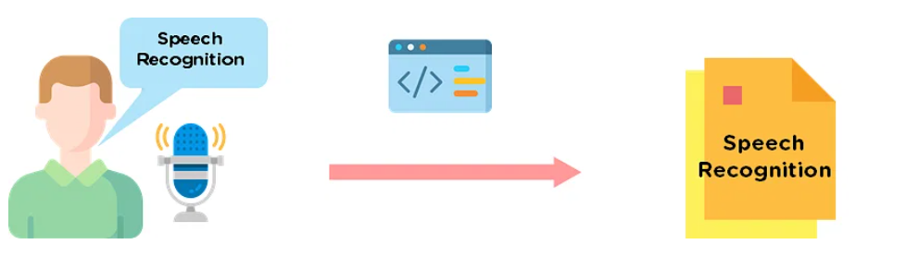

# Problem statement

Developing a robust and accurate speech recognition system is a challenging task due to the variability of human speech. Factors such as accent, background noise, and speaking rate can make it difficult for speech recognition systems to accurately transcribe spoken words.

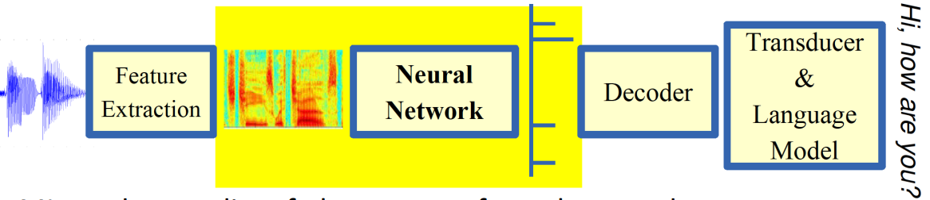

1. **Objective**

# The objective of this project is to develop a speech recognition system that is both accurate and robust. The system should be able to transcribe a variety of spoken words, including those with different accents, background noise, and speaking rates.

# Proposed Methodology

The project methodology involves a systematic approach:

* **Dataset Collection:** Assemble a comprehensive dataset with diverse speakers and speech samples.
* **Preprocessing:** Apply necessary preprocessing techniques to enhance signal quality.
* **Feature Extraction:** Extract relevant features from the audio signals to facilitate effective speaker identification.
* **Model Training:** Employ machine learning techniques to train the speaker identification model.
* **Performance Evaluation**: Assess the model's accuracy on a separate test set, emphasizing both overall accuracy and real-time efficiency.
* **Documentation**: Comprehensive documentation or report will be created to explain the solution, its design, and how it works.

# Block Diagram

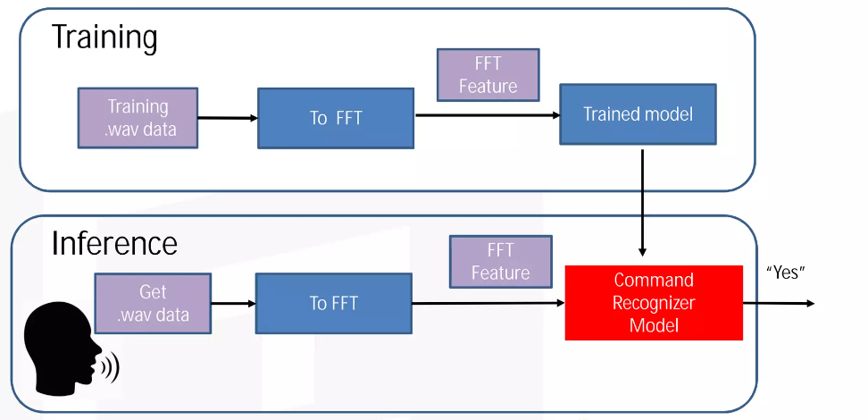

1. **Flowchart**

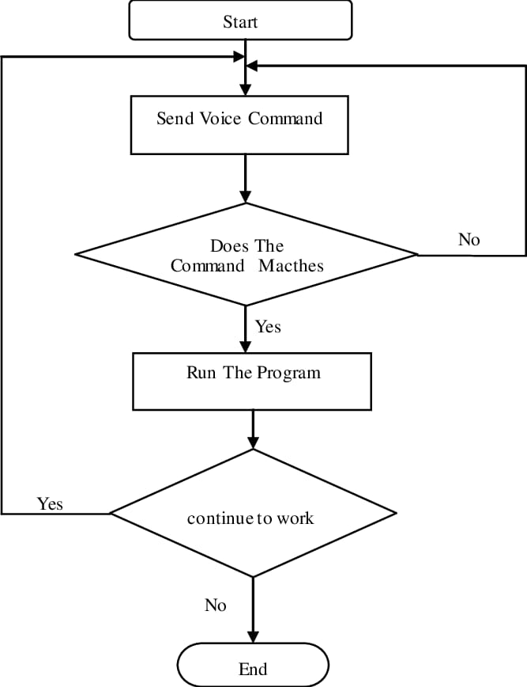

# Expected outcome/results

The project anticipates the development of a highly accurate and adaptable speaker identification system, showcasing superior performance in real-time scenarios. The expected outcome is a robust solution that enhances security measures, facilitates personalized interactions, and contributes valuable insights to the broader field of voice recognition technology.

1. **Applications**

The speech recognition system developed in this project will have a wide range of applications, including:

* Voice control for devices and appliances
* Transcription of audio recordings
* Accessibility for people with disabilities
* Medical dictation
* Customer service
* Education

**References**

* https://www.nist.gov/itl/iad/mig/nist-2021-speaker-recognition-evaluation-sre21
* https://cyberleninka.org/article/n/1101807#:~:text=Speaker%20recognition%20technology%20can%20provide,calling%20or%20banking%20access%20etc.